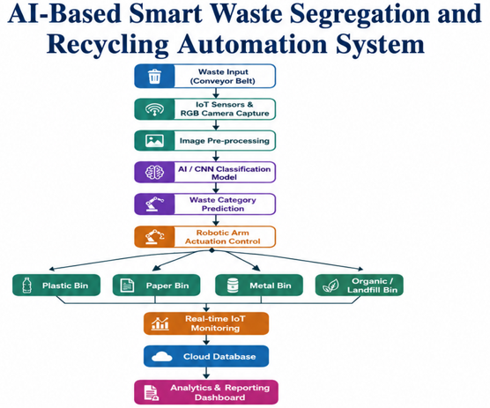

1. Introduction

1.1 Purpose
This Software Requirement Specification (SRS) document defines the functional and non-functional requirements for the AI-Based Smart Waste Segregation and Recycling Automation System. The document is intended to guide the design, development, testing, and deployment of a system that automates the identification and sorting of municipal solid waste using Artificial Intelligence (AI), Computer Vision, Robotics, and Internet of Things (IoT) technologies.

1.2 Industry Context
Efficient waste segregation is fundamental to sustainable waste management and recycling. Manual segregation is labor-intensive, error-prone, and often results in recyclable materials being discarded into landfills. AI, Computer Vision, Robotics, and IoT technologies enable automated waste identification and sorting, supporting circular economy initiatives and reducing the environmental footprint of municipal waste processing.

1.3 Business Domain and Stakeholders
The system operates in the Environmental Technology / Smart City Waste Management domain. Key stakeholders include municipal waste processing facility operators, recycling plant managers, waste collection staff, municipal corporations / regulatory bodies, environmental compliance auditors, and, indirectly, city residents who benefit from cleaner and more sustainable waste disposal.

1.4 System Objectives
- Classify waste into categories (recyclable, organic, hazardous, landfill) using AI-based computer vision.
- Automate waste segregation through robotic sorting mechanisms.
- Monitor recycling operations in real time.
- Reduce the volume of waste sent to landfills.
- Generate waste analytics and management reports.
- Improve overall recycling efficiency and accuracy.
- Support environmental sustainability and circular-economy goals.
- Minimize manual human intervention in the sorting process.

2. Problem Description
Improper segregation of municipal waste significantly reduces recycling efficiency and increases the volume of waste sent to landfills. Existing waste processing facilities largely depend on manual sorting, which is slow, inconsistent, physically strenuous, and prone to human error. Contaminated recyclable streams (e.g., recyclables mixed with organic or hazardous waste) lower the market value of recovered material and increase overall operational costs for processing facilities.
The proposed AI-Based Smart Waste Segregation and Recycling Automation System addresses this problem by using computer vision to identify waste categories in real time, directing robotic sorting mechanisms to automatically separate the waste, continuously monitoring recycling operations through IoT sensors, and generating analytics reports that help facility managers track recycling performance, landfill diversion, and operational costs. The platform is intended to raise recycling efficiency, cut operating costs, and reduce environmental pollution caused by improperly processed waste.

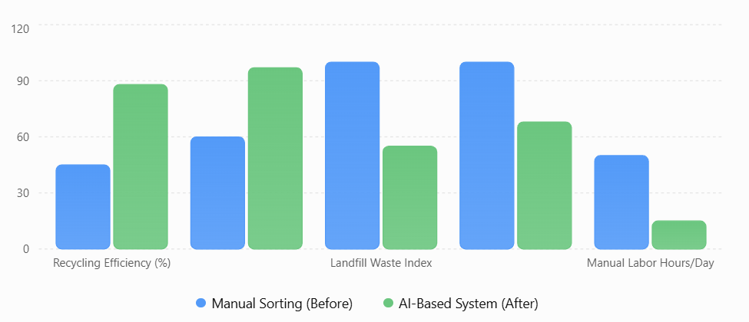
Figure: Comparison of Manual Waste Sorting and AI-Based Smart Waste Segregation System

Problem Analysis
The pie chart illustrates the major challenges in waste management. Improper waste segregation has the highest impact, followed by low recycling efficiency and increased landfill usage. These issues highlight the need for an AI-based smart waste segregation system to automate waste sorting, improve recycling accuracy, and reduce environmental pollution.

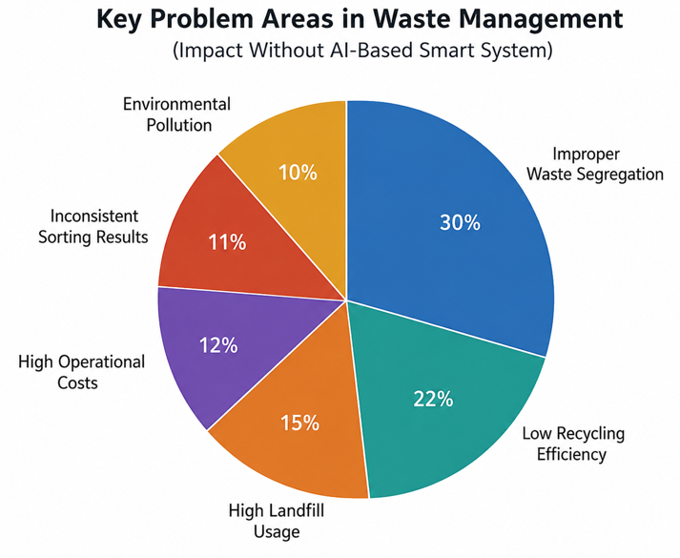
Figure: Distribution of Key Waste Management Problems
2.1 Existing Challenges
- Manual sorting is labor-intensive, slow, and creates unsafe working conditions when handling hazardous waste.
- High rate of misclassification leads to contaminated recyclable streams and material rejection.
- Lack of real-time visibility into sorting accuracy, throughput, and bin capacity.
- Limited historical data for regulatory reporting and process improvement.
- Rising landfill usage and associated environmental / compliance costs.

3. Scope of the System
The system will cover the end-to-end waste identification and sorting workflow at a municipal waste processing facility: image capture of waste items on an intake conveyor, AI-based classification, robotic actuation for physical segregation, sensor-based monitoring of bins and equipment, and generation of recycling and landfill-diversion reports for facility operators and management.
The scope excludes waste collection logistics/routing outside the facility, curb-side household bin collection scheduling, and downstream recycling material processing (e.g., shredding, pelletizing) performed by third-party recycling plants beyond report-level integration.

4. Functional Requirements
ID | Functional Requirement | Priority
FR-01 | The system shall capture images of waste items on the intake conveyor using industrial cameras. | High
FR-02 | The system shall classify each waste item into categories (recyclable, organic, hazardous, landfill) using an AI/computer-vision model. | High
FR-03 | The system shall direct a robotic sorting arm / diverter to move classified waste into the correct bin. | High
FR-04 | The system shall log every classification and sorting event with timestamp, category, and confidence score. | High
FR-05 | The system shall flag low-confidence classifications for manual review or re-scanning. | Medium
FR-06 | The system shall monitor bin fill-levels and equipment status using IoT sensors. | High
FR-07 | The system shall send real-time alerts to facility operators when a bin is full or a fault is detected. | Medium
FR-08 | The system shall generate waste analytics and recycling reports (daily, weekly, monthly). | High
FR-09 | The system shall provide a dashboard displaying live recycling statistics and landfill-diversion metrics. | Medium
FR-10 | The system shall allow administrators to configure classification rules and sorting thresholds. | Medium
FR-11 | The system shall authenticate users and enforce role-based access control (Operator, Manager, Administrator). | High
FR-12 | The system shall maintain an audit trail of configuration changes and manual overrides. | Low

5. Non-Functional Requirements
Category | Requirement
Performance | The AI classification module shall classify a waste item within 300 milliseconds to keep pace with conveyor speed.
Scalability | The system shall support horizontal scaling to accommodate additional sorting lines/cameras at new facilities without redesign.
Reliability | The system shall maintain 99.5% uptime during facility operating hours, with automatic failover for the classification service.
Security | All sensor data, video feeds, and reports shall be encrypted in transit and at rest; access shall follow role-based permissions.
Usability | The operator dashboard shall be usable by staff with minimal technical training, following a simple, icon-driven interface.
Maintainability | The AI model shall support periodic retraining/updating without requiring downtime of the physical sorting line.
Availability | Critical sorting and safety-stop functions shall remain available even during partial network outages (local fail-safe mode).
Interoperability | The system shall expose APIs to integrate with municipal waste-management and regulatory reporting platforms.

6. Actors and Use Cases

6.1 Actors
Actor | Type | Description
Waste Collection Staff | Primary | Loads waste onto the intake conveyor and performs manual re-scans when flagged.
Facility Operator | Primary | Monitors the sorting line, responds to alerts, and manages day-to-day operations.
Recycling Plant Manager | Primary | Reviews analytics/reports and makes operational and procurement decisions.
System Administrator | Primary | Configures classification rules, manages users, and maintains system settings.
IoT Sensor & Camera Network | Secondary (external) | Supplies real-time image and sensor data to the classification engine.
Robotic Sorting Arm | Secondary (external) | Executes physical sorting actions issued by the system.

6.2 Use Case Diagram
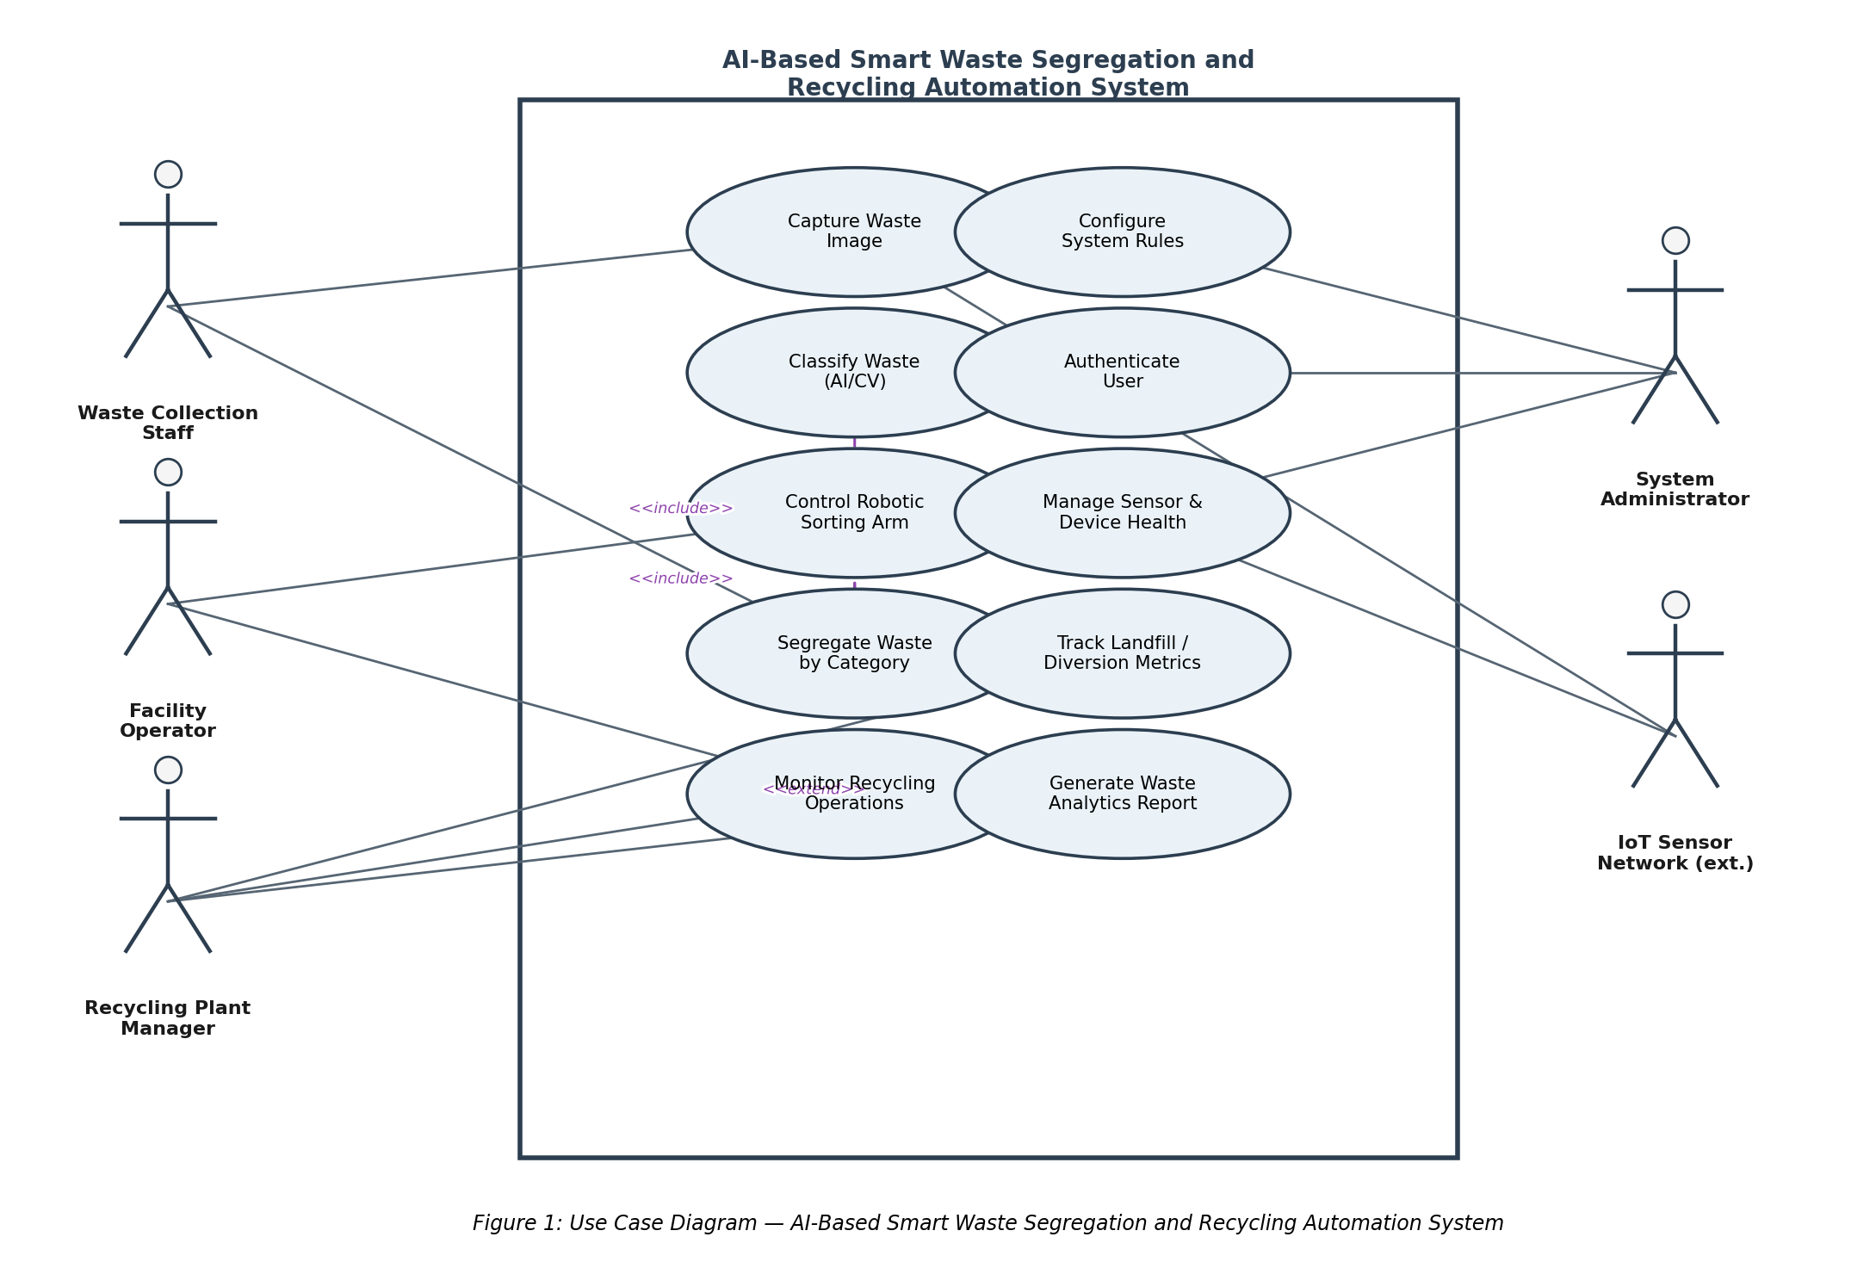

6.3 Use Case Descriptions
Use Case | Primary Actor | Description
Capture Waste Image | Waste Collection Staff / Sensors | Camera captures an image of the waste item as it passes the intake point.
Classify Waste (AI/CV) | System (AI engine) | The AI model analyzes the captured image and predicts the waste category and confidence score.
Control Robotic Sorting Arm | System / Robotic Arm | System issues an actuation command directing the item to the correct bin.
Segregate Waste by Category | System | End-to-end process combining classification and robotic actuation to physically separate waste.
Monitor Recycling Operations | Facility Operator / Plant Manager | View live dashboard of sorting throughput, accuracy, and bin status.
Generate Waste Analytics Report | Recycling Plant Manager | Produce periodic reports summarizing recycling rates and landfill diversion.
Manage Sensor & Device Health | System Administrator | Monitor and maintain camera, sensor, and robotic-arm operational status.
Authenticate User | All Actors | Verify user identity and enforce role-based access before granting system access.
Configure System Rules | System Administrator | Adjust classification thresholds, bin mappings, and alert rules.

7. Process Flow
The AI-Based Smart Waste Segregation and Recycling Automation System follows an automated workflow to identify, classify, and sort waste efficiently. Waste images are captured using IoT sensors and cameras, analyzed by an AI model, and directed to the appropriate bin through robotic mechanisms. The system continuously monitors operations, updates the recycling dashboard in real time, and generates waste analytics reports, ensuring improved recycling efficiency and reduced manual intervention.
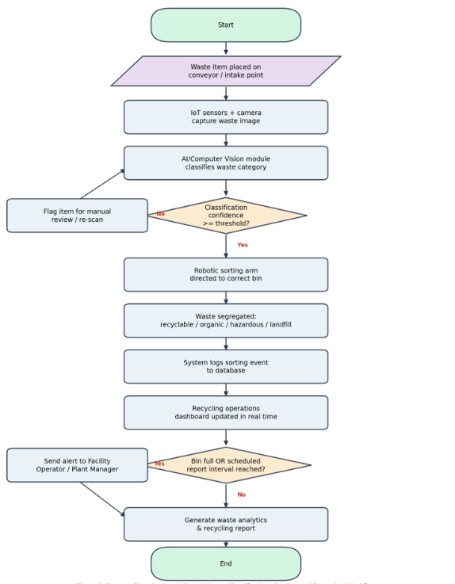
Figure: Process Flowchart of AI-Based Smart Waste Segregation and Recycling Automation System

8. Data Requirements
Data Entity | Key Attributes
Waste Item Record | Item ID, Timestamp, Captured Image Reference, Predicted Category, Confidence Score, Sorting Outcome
Sensor / Device | Device ID, Type (Camera/IoT/Robotic Arm), Location, Status, Last Health-Check Timestamp
Bin | Bin ID, Category, Current Fill Level, Capacity, Location
User Account | User ID, Name, Role (Operator/Manager/Administrator), Access Permissions
Report | Report ID, Period, Recycling Rate, Landfill Diversion Rate, Generated By, Generated On
Alert / Event Log | Event ID, Type (Bin Full/Fault/Low Confidence), Timestamp, Status, Handled By

9. External Interface Requirements

9.1 User Interfaces
- Web-based operator dashboard for live monitoring of sorting status and alerts.
- Admin console for configuring classification rules, users, and thresholds.
- Report viewer for recycling plant managers with export options (PDF/Excel).

9.2 Hardware Interfaces
- Industrial cameras positioned above the intake conveyor.
- IoT sensors for bin-level, temperature, and equipment-health monitoring.
- Robotic sorting arm / pneumatic diverter actuators.

9.3 Software Interfaces
- AI/Computer Vision inference service (REST/gRPC API).
- Database service for transactional and historical data storage.
- Integration API for municipal waste-management and regulatory reporting systems.

9.4 Communication Interfaces
- MQTT / HTTPS protocols for IoT sensor and device communication.
- Secure REST APIs for dashboard and third-party integration.

10. System Features
Feature | Description
Real-Time Waste Classification | Uses a trained computer-vision model to identify waste category from live camera feed.
Automated Robotic Sorting | Physically separates classified waste using robotic arms/diverters with minimal latency.
Live Operations Dashboard | Displays sorting throughput, accuracy, bin levels, and equipment status in real time.
Analytics & Reporting | Generates recycling-rate, landfill-diversion, and cost-efficiency reports on demand or schedule.
Alerting & Notifications | Notifies relevant staff of full bins, low classification confidence, or equipment faults.
Role-Based Access Control | Restricts configuration and reporting functions according to user role.

11. Assumptions and Constraints

11.1 Assumptions
- Adequate and consistent lighting is available at the camera capture point for reliable image classification.
- The facility has stable network connectivity between IoT devices, the classification engine, and the central server.
- A labeled training dataset representative of the facility's waste stream is available for the AI model.
- Facility staff will receive basic training to operate the dashboard and respond to alerts.
- The robotic sorting hardware is compatible with the system's control API.

11.2 Constraints
Type | Constraint
Technical | AI classification accuracy is dependent on training-data quality and may degrade for novel or heavily soiled waste items.
Operational | System must operate continuously during facility shift hours with minimal planned downtime for maintenance.
Economic | Budget limits the number of camera/sensor units and the scale of the initial robotic sorting deployment.
Legal / Regulatory | The system must comply with municipal waste-handling regulations and environmental reporting standards.
Time | Initial deployment must be completed within the facility's defined project timeline / academic assessment duration.

12. Requirement Validation — Completeness and Consistency

12.1 Stakeholder Coverage Check
All identified stakeholders — Waste Collection Staff, Facility Operator, Recycling Plant Manager, and System Administrator — have at least one corresponding functional requirement and use case, confirming that stakeholder needs identified in Section 1.3 are addressed in Sections 4 and 6.

12.2 Ambiguity, Redundancy, and Inconsistency Review
Check | Finding | Resolution
Ambiguity | Original term "identify different categories of waste" did not specify exact categories. | Explicitly defined four categories: recyclable, organic, hazardous, landfill (FR-02).
Redundancy | "Automate waste segregation" and "reduce manual intervention" objectives overlapped. | Consolidated into a single functional requirement (FR-03) with FR-05 as the exception path.
Missing Requirement | No explicit requirement existed for handling low-confidence AI predictions. | Added FR-05 (manual review flagging) to prevent silent misclassification.
Missing Requirement | No access-control requirement was present in the original problem statement. | Added FR-11 and role-based NFR to protect configuration and reporting functions.
Consistency | Reporting objective and monitoring objective were listed separately but are related. | Linked via <<extend>> relationship in the use case diagram (Section 6.2).

12.3 Improvement Suggestions
- Define measurable acceptance thresholds (e.g., minimum classification accuracy %) during the design phase.
- Add a data-retention and privacy policy for stored waste images to strengthen the security NFR.
- Introduce a feedback loop where manually corrected classifications are used to retrain the AI model periodically.
- Conduct a pilot run with a small waste stream sample to validate end-to-end requirement completeness before full deployment.

13. Conclusion
This Software Requirements Specification (SRS) document provides a comprehensive description of the AI-Based Smart Waste Segregation and Recycling Automation System. It defines both the functional requirements, such as AI-based waste classification, robotic waste segregation, IoT-based monitoring, and analytics reporting, and the non-functional requirements, including performance, reliability, security, scalability, and usability. The document also identifies the system actors, use cases, data requirements, interface specifications, assumptions, constraints, and expected system behavior to ensure a clear understanding of the proposed solution.
The requirement validation process involved reviewing the requirements for correctness, completeness, consistency, feasibility, and traceability. Feedback from stakeholders was considered to eliminate ambiguities, resolve conflicts, and ensure that all essential system functionalities were accurately captured. As a result, the SRS establishes a well-defined and reliable baseline for the subsequent phases of system design, implementation, testing, deployment, and maintenance.
By following the requirements specified in this document, the AI-Based Smart Waste Segregation and Recycling Automation System can be developed as an efficient, intelligent, and sustainable solution that improves waste segregation accuracy, increases recycling efficiency, reduces landfill waste, minimizes operational costs, and supports environmental sustainability through advanced AI, Computer Vision, Robotics, and IoT technologies.

